1. what is Data?

* **ANS**: Data is a raw unorganized facts or Plain facts

1. what is Information?

* **ANS**: it is a processed data plus the meaning of what the data was collected for

1. what is Database(DB)?

* Ans: It is an organized collection of data. More specifically, a database is an electronic system that allows data to be easily accessed, manipulated and updated.
* A database is **an organized collection of structured information, or data, typically stored electronically in a computer system**. A database is usually controlled by a database management system (DBMS).

1. What is the Relation Database Management System(RDBMS)?

* **ANS**: **The software used to store, manage, query, and retrieve data stored in a relational database** is called a relational database management system (RDBMS).

1. Define the importance of Relation Database Management System(RDBMS)?

* **ANS:** The RDBMS provides an interface between users and applications and the database, as well as administrative functions for managing data storage, access, and performance.

1. As we all know that there are Two types of Database. Relational Database(SQL) AND Non-Relational DB(NO sql). what is the difference between them?

**ANS :**

* **A relational database**, also called Relational Database Management System (RDBMS) or SQL database, stores data in tables and rows also referred to as records. A relational database works by linking information from multiple tables through the use of “*keys*.”
* **Non-Relational DB(NO sql):** The non-relational database, or NoSQL database, stores data. However, unlike the relational database, there are no tables, rows, primary keys or foreign keys.  Instead, the non-relational database uses a storage model optimized for specific requirements of the type of data being stored.
* There are four popular non-relational types: document data store, column-oriented database, key-value store and graph database.  Often combinations of these types are used for a single application

1. List examples of Relation Database Management System (RDBMS)?

* **ANS:** Popular examples of standard relational databases include **Microsoft SQL Server, Oracle Database, MySQL and IBM DB2**. Cloud-based relational databases, or database as a service, are also widely used because they enable companies to outsource database maintenance, patching and infrastructure support requirements.

1. List examples of Non-Relational DB(No. sql)?

* **ANS:** Some of the more popular NoSQL databases are MongoDB, Apache Cassandra, Redis, Couchbase and Apache HBase.
* **ANS:** There are four popular non-relational types: document data store, column-oriented database, key-value store and graph database.  Often combinations of these types are used for a single application.

1. Define and Describe is Structured Query Language (SQL)?

* **ANS:** Querying the data in a relational database management system is done by using Structured Querying Language (SQL), which is a robust language designed for managing the data housed in a relational database.

1. List and describe each of the different subsets of SQL (Mean DDL, DML, DCL, TCL)?

**ANS:**

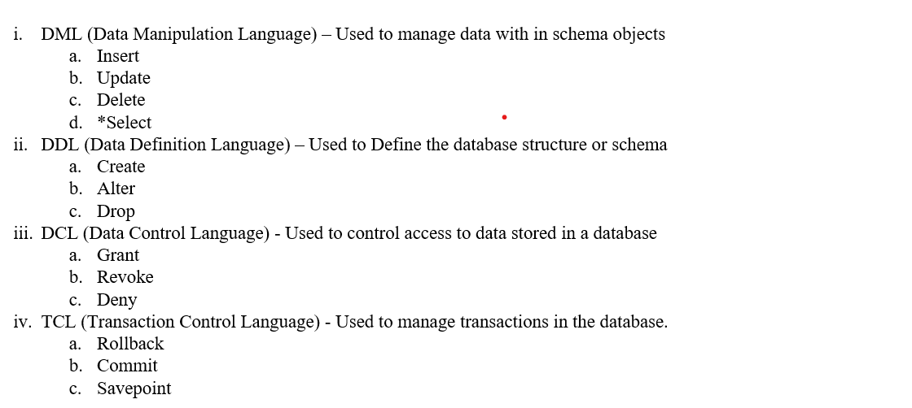

1. what is table in Database (DB)?

* **ANS:** Data in the database is stored in a table. It is comprised of rows and columns. A table is usually used to store unique information e.g a customer’s table, purchases, sales, students, etc.

1. what is column and Row(tuples) in table?

* **ANS:** **A tuple is simply a row contained in a table in the tablespace**. A table usually contains columns and rows in which rows stand for records while columns stand for attributes. A single row of a table that has a single record for such a relation is known as a tuple.